BIS LAB- 1WN24CS139

LAB 1:GENETIC ALGORITHM -FRACTIONAL KNAPSACK
import random
ITEMS = [(60, 10), (100, 20), (120, 30)]
CAPACITY = 50
pop = [[random.random() for _ in ITEMS] for _ in range(100)]
def fitness(ind):
w = sum(f * item[1] for f, item in zip(ind, ITEMS))
v = sum(f * item[0] for f, item in zip(ind, ITEMS))
return v if w <= CAPACITY else 0

for g in range(1, 10):
pop.sort(key=fitness, reverse=True)
best_v = fitness(pop[0])
print(f"Gen {g:2d} | Best Fractions: {[round(f, 2) for f in pop[0]]} | Value: {best_v:.1f}")
if best_v >= 240: break

pool = pop[:30]
pop = pop[:5] + [
[
random.random() if random.random() < 0.1
else random.choice([p1_gene, p2_gene])
for p1_gene, p2_gene in zip(random.choice(pool), random.choice(pool))
]
for _ in range(15)
]

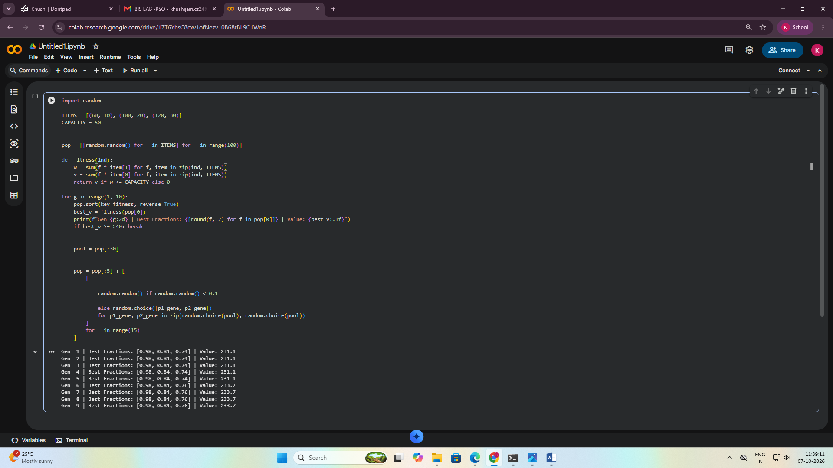

Lab 2:PARTICLE SWARM OPTIMISATION-TSP
import random, math
cities = [(0,0), (2,3), (5,2), (6,6), (1,5)]
def distance(route):
d = 0
for i in range(5):
d += math.dist(cities[route[i]], cities[route[(i+1)%5]])
return d
particles = [random.sample(range(5), 5) for _ in range(5)]
best = min(particles, key=distance)
for _ in range(50):
for p in particles:
new = p.copy()
a, b = random.sample(range(5), 2)
new[a], new[b] = new[b], new[a]
if distance(new) < distance(p):
p[:] = new
if distance(p) < distance(best):
best = p.copy()
print("Best Route:", best)
print("Shortest Distance:", round(distance(best), 2))

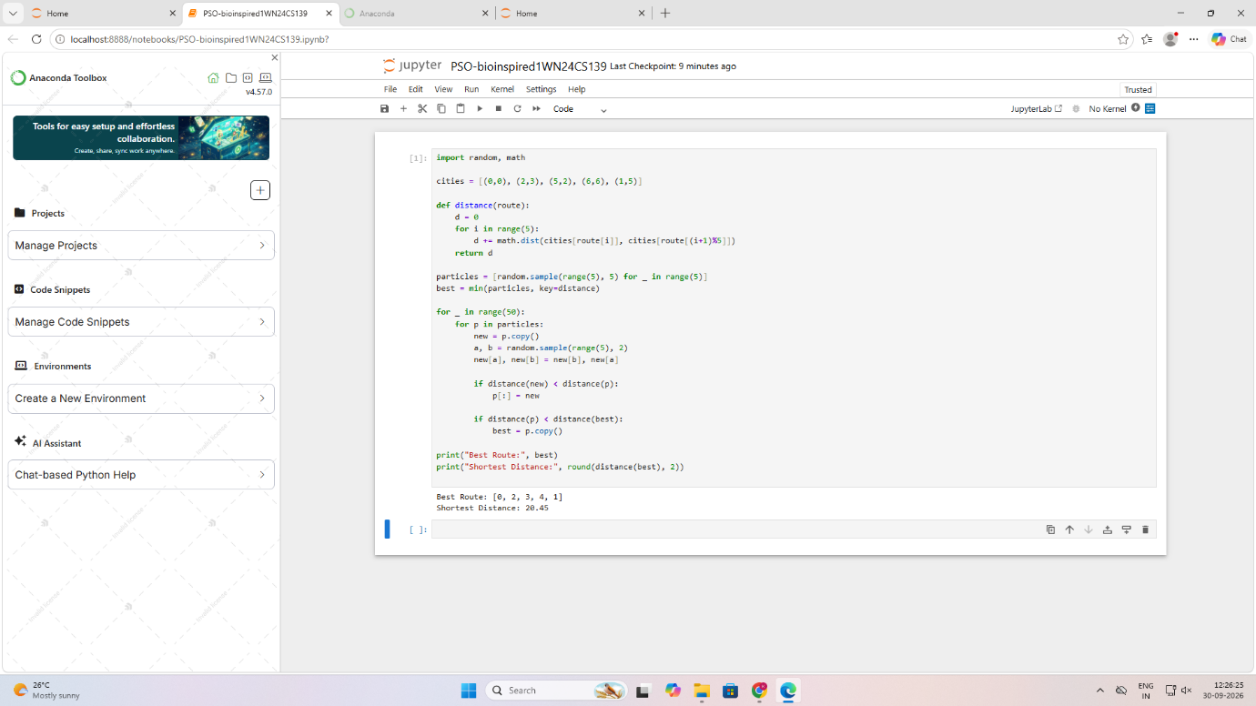

LAB 3:OPTIMISATION VIA GENE EXPRESSION -ROUTE OPTIMISATION
import random

cities = [0, 1, 2, 3]
distance = [
[0, 10, 15, 20],
[10, 0, 35, 25],
[15, 35, 0, 30],
[20, 25, 30, 0]]

def fitness(route):
total = 0
for i in range(len(route) - 1):
total += distance[route[i]][route[i+1]]
return total

best = None
best_distance = 9999

for _ in range(100):
route = random.sample(cities, len(cities))
d = fitness(route)

if d < best_distance:
best = route
best_distance = d

print("Best Route:", best)
print("Distance:", best_distance)

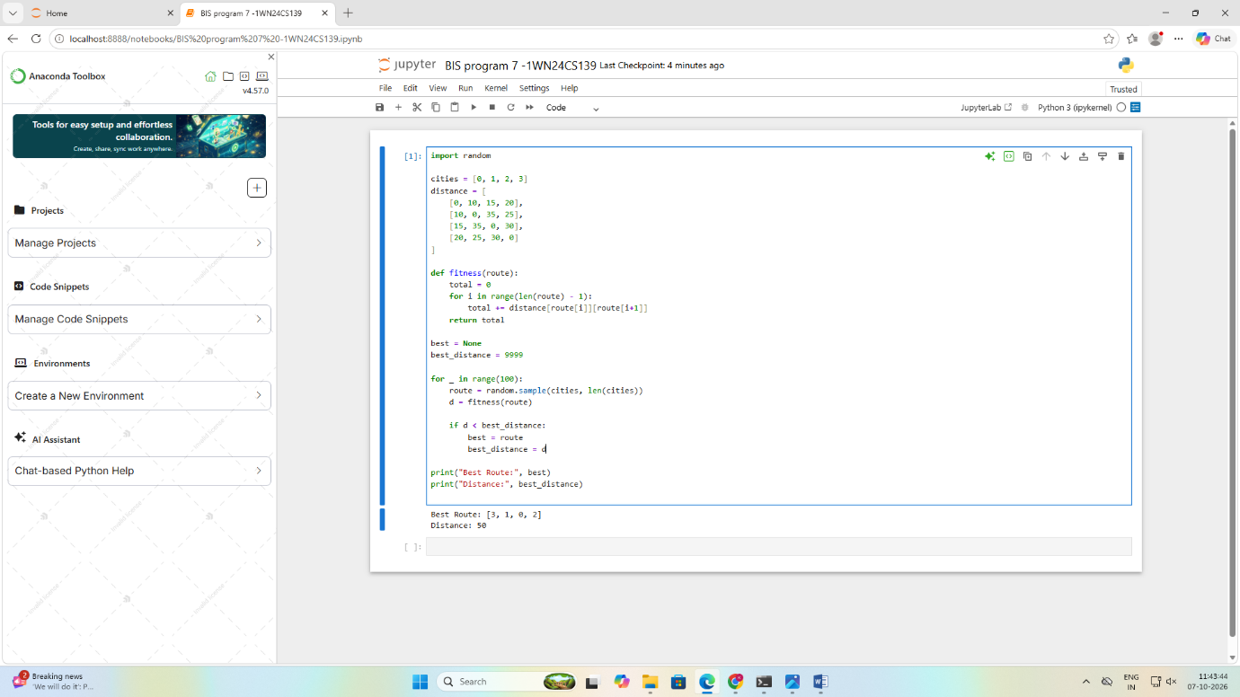

LAB 4:ANT COLONY OPTIMISATION
import random
d = [[0, 2, 3],
[2, 0, 4],
[3, 4, 0]]
n = len(d)
p = [[1]*n for _ in range(n)]
best, cost = None, float('inf')
for _ in range(20):
path = [random.randrange(n)]
while len(path) < n:
c = [i for i in range(n) if i not in path]
path.append(max(c, key=lambda x: p[path[-1]][x]/d[path[-1]][x]))
total = sum(d[path[i]][path[(i+1)%n]] for i in range(n))
if total < cost:
best, cost = path[:], total
for i in range(n):
a, b = path[i], path[(i+1)%n]
p[a][b] += 1/total
print("Path:", best + [best[0]])
print("Cost:", cost)
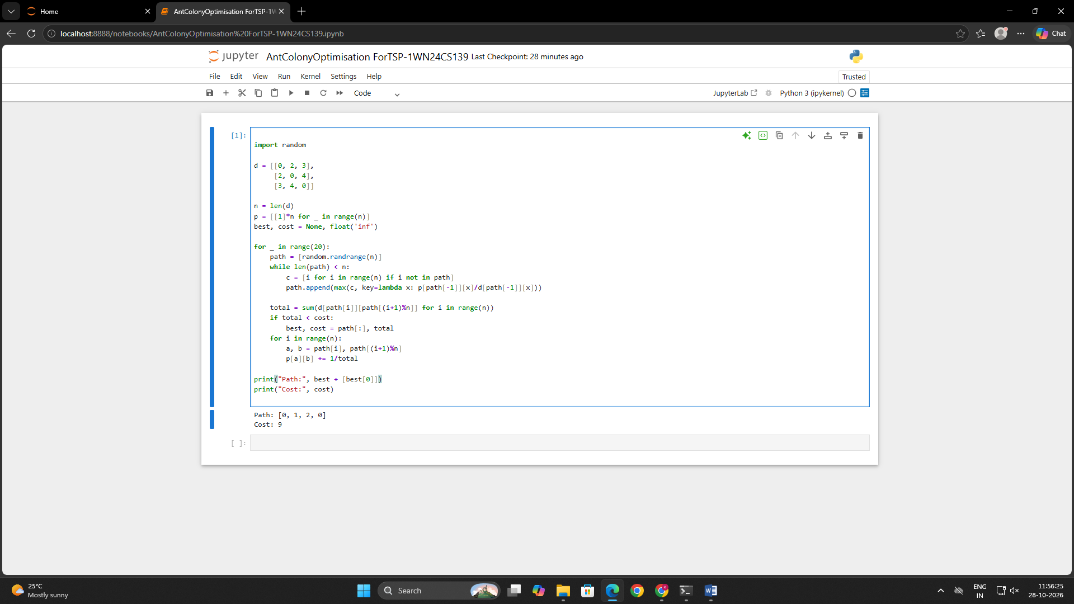

LAB 5:GREY WOLVES OPTIMISATION
import numpy as np
from sklearn.ensemble import RandomForestClassifier
# URL features: length, dots, HTTPS, @ symbol
X = np.array([
[20,1,1,0], [30,2,1,0],
[90,5,0,1], [100,6,0,1],
[25,1,1,0], [80,4,0,1]])
y = [0,0,1,1,0,1] # 0=Safe, 1=Malicious
wolves = np.random.randint(0, 2, (5, 4))
for i in range(10):
best = wolves[0].copy()
wolves = np.where(np.random.rand(5,4) > 0.5, best, wolves)
model = RandomForestClassifier(random_state=42)
model.fit(X, y)
url = np.array([[90,5,0,1]])
result = model.predict(url)
print("URL Status:",
"Malicious" if result[0] else "Safe")
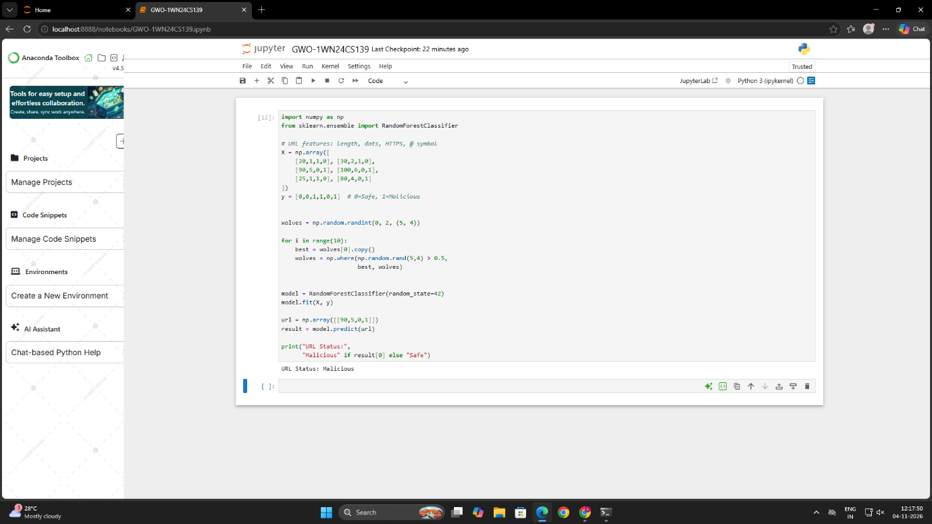
LAB :CUCKOO SEARCH ALGORITHM
import numpy as np
import math

processing_time = np.array([5, 2, 8, 3, 6, 4])
weight = np.array([3, 5, 2, 4, 1, 3])

n = len(processing_time)

n_nests = 10
Pa = 0.25
max_iter = 100
alpha = 0.1
beta = 1.5

def fitness(position):
order = np.argsort(position)

completion_time = 0
total_cost = 0

for job in order:
completion_time += processing_time[job]
total_cost += weight[job] * completion_time

return total_cost

def levy_flight(size):
sigma = (
math.gamma(1 + beta) * math.sin(math.pi * beta / 2)
/ (math.gamma((1 + beta) / 2) * beta *
2 ** ((beta - 1) / 2))
) ** (1 / beta)

u = np.random.normal(0, sigma, size)
v = np.random.normal(0, 1, size)

step = u / (np.abs(v) ** (1 / beta))
return step

nests = np.random.rand(n_nests, n)
scores = np.array([fitness(x) for x in nests])

best_index = np.argmin(scores)
best_nest = nests[best_index].copy()
best_score = scores[best_index]

for iteration in range(max_iter):

for i in range(n_nests):

new_solution = nests[i] + alpha * levy_flight(n)
new_solution = np.clip(new_solution, 0, 1)

new_score = fitness(new_solution)

j = np.random.randint(n_nests)

if new_score < scores[j]:
nests[j] = new_solution
scores[j] = new_score

abandon_count = max(1, int(Pa * n_nests))

worst_indices = np.argsort(scores)[-abandon_count:]

for j in worst_indices:
nests[j] = np.random.rand(n)
scores[j] = fitness(nests[j])

best_index = np.argmin(scores)

if scores[best_index] < best_score:
best_score = scores[best_index]
best_nest = nests[best_index].copy()

best_order = np.argsort(best_nest)

print("Best Job Scheduling Order:")

for job in best_order:
print("Job J" + str(job + 1), end=" -> ")

print("\nMinimum Weighted Completion Time:", best_score)



